Expressions of Interest

|  |
| --- |
| [Save the Children International] |

|  |  |
| --- | --- |
| Invitation title: | [Expression of Interest for Educational Equipment (Student Seating)] |
| Reference number: | [#12] |
| Date of issue: | [14th August 2021] |

Omer Sharfy

Head of Supply Chain

# Introduction

SCI is the world's leading independent organisation for children. Our Vision is a world in which every child attains the right to survival, protection, development and participation, our Mission is to inspire breakthroughs in the way the world treats children, and to achieve immediate and lasting change in their lives.

SCI is seeking supplier’s response to the invitation for the supply of goods and/or services in Educational Equipment (Student Seating) sector as outlined in Part A.2.

SCI seeks to gain a more detailed understanding of the supplier market and range of solutions that may be available. Hence, this EOI process may be the first stage of a multi‑stage procurement process. For further information, relating to the next stage (if any) of the EOI process refer to clause 6 of Part B.2.

Professional procurement is crucial to enabling SCI to deliver high quality programs on time and to budget, helping us to meet our commitments to beneficiaries and donors. Furthermore, between 30%-50% of our total income is spent on suppliers, making it SCI's single largest cost. By making this financial resource go further, it creates opportunities for our budget holders and programmes to have a greater impact.

## Structure of the invitation

This Invitation comprises the following sections:

* Introduction – contains an overview of the structure of the documents.
* Part A – The Invitation
  + Part A.1 – About this Invitation provides establishment details about the procurement opportunity; and
  + Part A.2 – Overview of requirements describes the goods and/or services in respect of which the organisation invites EOIs from interested parties.
* Part B – Conditions of participation sets out the rules applying to the EOI process for the supply of goods and/or services.
* Part C – Supplier’s response details the information to be provided by suppliers.
* Part D – Appendex

# Part A – The invitation

Part A.1 – About this invitation

1. Establishment details

|  |  |
| --- | --- |
| Organisation name: | Save The children International |
| EOI title: | Expression of Interest for Educational Equipment (Student Seating) |
| EOI reference number | #12 |

1. Organisation contact

|  |  |
| --- | --- |
| Head of Procurement |  |
| Name: | Omer Sharfy |
| Position title: | Head of Supply Chain |
| Department: | Procurement |
| Contact details: | Omer.sharfy@savethechildren.org |

|  |  |
| --- | --- |
| For Any Queries please contact: |  |
| Name: | Mohammed Malik |
| Mobile Number: | 00249911252670 |
| Department: | Procurement Lead |
| Contact details: | Mohammed.malik@savethechildren.org |

1. Closing time

|  |  |
| --- | --- |
| Closing time |  |
| To be returned to [**sudanco.procurement@savethechildren.org**](mailto:sudanco.procurement@savethechildren.org)or by hand to Save the Children HQ Off 117 Street, near Rashideen Mosque- Al Riyadh Area - 00249911252670 | **12:00 pm Thursday 21st April 2022** |

1. Indicative timetable

Please note: this timetable provides suppliers with an indication of the timing of the EOI process. The timetable is indicative only and may be changed by the organisation in accordance with clause 5.1 of Part B.2.

| Activity | Date |
| --- | --- |
| Invitation issued | 14th April 2022 |
| Closing Date and submission | 21st April 2022 |
| Intended completion date of short-listing process | 28th April 2022 |
| Intended completion date of evaluation of supplier’s responses | 16th May 2022 |

1. Evaluation criteria

A supplier’s response will be evaluated against:

(a) The evaluation criterias identified in the table below; and

(b) the overall proposition presented in the supplier’s response.

|  |  |
| --- | --- |
| Essential Criteria | Complies |
| Certification of Valid Tax Compliance | Yes/No |
| VAT certificate | Yes/No |
| Proof of legitimate business address | Yes/No |

Part A.2 – Overview of requirements

SCI is a large organization with multiple offices working across Sudan and they are on constent need for Educational Materials, listed below are the majority of SCI requrements, apart from odd requests.

|  |  |
| --- | --- |
| Requirement | Details |
| Educational Materials | * (School Seating)   (MDF wood 17 mL, 2.5x5 pipe for the metal legs and 1.5x3 for the in between pipes)  See Pictures Below for reference. |

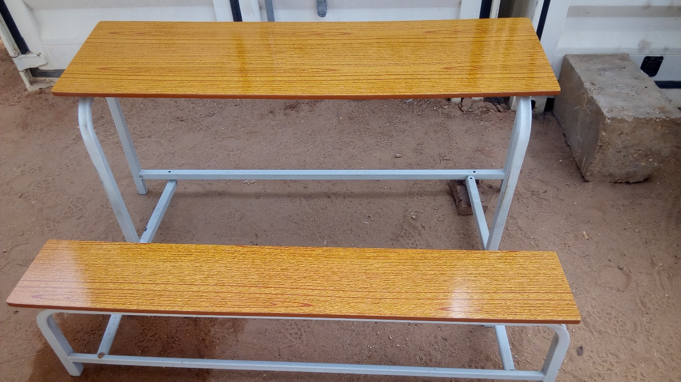

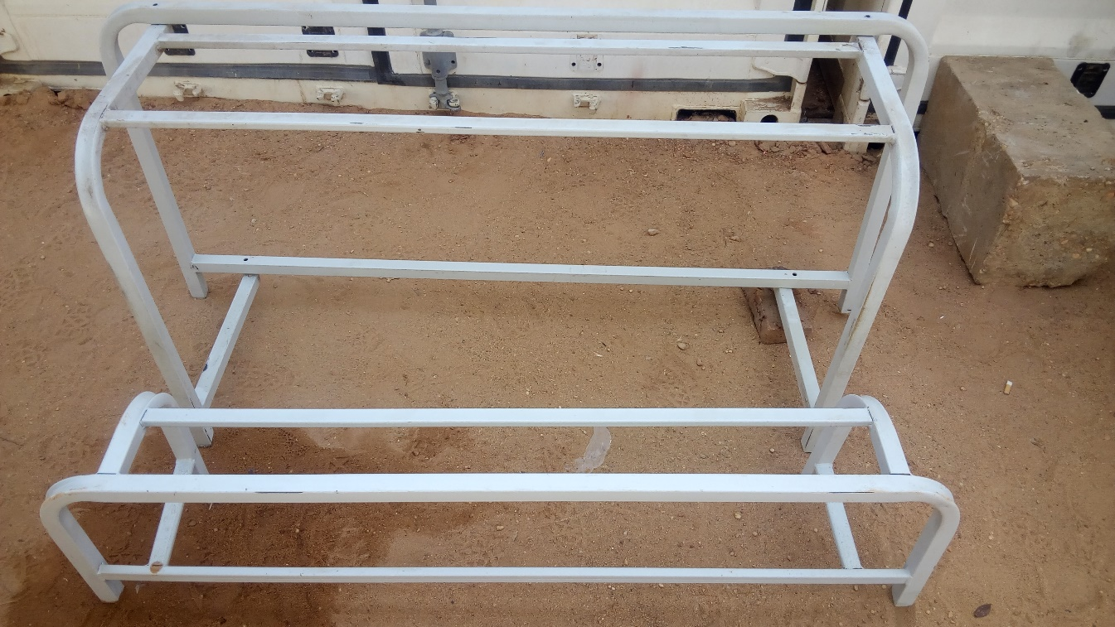

**Part B. 1 – Perferable Criteria**

1. Experience with the same supplies and services with any reputed business enitiy/organization.

Name of Client

Referance Name and Email for verification

Suppliers to Agree on Save the Children payment terms i.e. *payment after delivery.*

# Part B – Conditions of participation

Part B.1 – SCI’s specific requirements

1. Definitions

In addition to the terms defined in the Cover Letter, in these Conditions, the following definitions apply:

(a) **Award Criteria** - the award criteria set out in the Expression of Interest.

(b) **Supplier** - the party which provides Goods and/or Services to SCI.

(c) **Goods and/or Services** - everything purchased by SCI under the contract.

(d) **Expression of Interest** – is part of a qualification *process* to receive information from the supplier that demonstrates the capacity to perform a contract and can result in the supplier entering a negotiation for a contract or being shortlisted for a subsequent tender.

(e) **SCI** - Save the Children International (formerly known as The International Save the Children Alliance Charity), a charitable company limited by guarantee registered in England and Wales (company number 03732267; charity number 1076822) whose registered office is at St Vincent House, 30 Orange Street, London, WC2H 7HH.

(f) **Specification** - any specification for the Goods and/or Services, including any related plans and drawings, supplied by SCI to the Supplier, or specifically produced by the Supplier for SCI, in connection with the tender.

1. **Late supplier responses**

Responses received after the Closing Date will not be considered, unless there are in SCI’s sole discretion exceptional circumstances which have caused the delay.

1. **Correspondence**

All communications from Potential suppliers to SCI relating to the EOI must be in writing and addressed to the person identified in this Invitation to Tender. Any request for information should be received at least 5 days before the Closing Date, as defined in the EOI. Where appropriate responses to questions submitted by any Potential supplier will be circulated by SCI to all Potential suppliers to ensure fairness in the process.

1. **Acceptance of responses**

SCI may, unless the Potential supplier expressly stipulates to the contrary in the EOI, accept whatever part of a response that SCI so wishes. SCI is under no obligation to accept the lowest or any responses.

1. **Prices**

Supplier’s prices must be shown as both inclusive of and exclusive of any Value Added Tax chargeable or any similar tax (if applicable).

1. **No reimbursement of tender expenses**

Expenses incurred in the preparation and dispatch of the tender will not be reimbursed.

1. **Non-Disclosure and Confidentiality**

Suppliers must treat the EOI and all associated documentation (including the Specification) and any other information relating to SCI’s employees, servants, officers, partners or its business or affairs (the "**Confidential Information**”) as confidential. All suppliers shall:

* recognise the confidential nature of the Confidential Information;
* respect the confidence placed in the Potential supplier by SCI by maintaining the secrecy of the Confidential Information;
* not employ any part of the Confidential Information without SCI's prior written consent, for any purpose except that of tendering for business from SCI;
* not disclose the Confidential Information to third parties without SCI's prior written consent;
* not employ their knowledge of the Confidential Information in any way that would be detrimental or harmful to SCI;
* use all reasonable efforts to prevent the disclosure of the Confidential Information to third parties;
* notify SCI immediately of any possible breach of the provisions of this Condition 9 and acknowledge that damages may not be an adequate remedy for such a breach.

1. **Information and Record Keeping**

SCI shall consider any reasonable request from any unsuccessful Supplier for feedback on its EOI and, where it is appropriate and proportionate to do so, provide the unsuccessful supplier with reasons why the response was rejected.

1. **Anti-Bribery and Corruption**

All suppliers are required to comply fully with SCI’s Anti-Bribery and Corruption Policy (attached to these Conditions).

1. **Child Protection**

All suppliers are required to comply fully with SCI’s Child Safeguarding Policy (attached to these Conditions).

1. **Human Trafficking and Modern Slavery**

All suppliers are required to comply fully with SCI’s Human Trafficking and Modern Slavery Policy (attached to these Conditions).

1. **Exclusion Criteria**

Any supplier is required to confirm in writing that:

* Neither it nor any related company to which it regularly subcontracts is insolvent or being wound up, is having its affairs administered by the courts, has entered into an arrangement with creditors, has suspended business activities, is the subject of proceedings concerning those matters, or are in any analogous situation arising from a similar procedure provided for in national legislation or regulations;
* Neither it nor a company to which it regularly subcontracts has been convicted of fraud, corruption, involvement in a criminal organisation, any money laundering offence, any offence concerning professional conduct, breaches of applicable labour law or labour tax legislation or any other illegal activity by a judgment in any court of law whether national or international;
* Neither it nor a company to which it regularly subcontracts has failed to comply with its obligations relating to the payment of social security contributions or the payment of taxes in accordance with the legal provisions of the relevant country in which it the Potential supplier operates.

Any supplier will automatically be excluded from the tender process if it is found that they are guilty of misrepresentation in supplying the required information within their tender bid or fail to supply the required information.

1. **Conflict of Interest / Non Collusion**

Any supplier is required to confirm in writing:

* That it is not aware of any connection between it or any of its directors or senior managers and the directors and staff of SCI which may affect the outcome of the selection process. If there are such connections the Potential supplier is required to disclose them.
* Whether or not there are any existing contacts between SCI, and any other Save the Children entity, and it and if there are any arrangements which have been put in place over the last twenty four (24) months.
* That it has not communicated to anyone other than SCI the amount or approximate amount of the tender.
* That it has not and will not offer pay or give any sum of money commission, gift, inducement or other financial benefit directly or indirectly to any person for doing or omitting to do any act in relation to the tender process.

1. **Assignment and novation**

All suppliers are required to confirm that they will if required be willing to enter into a contract on similar terms with either SCI or any other Save the Children entity if so required.

## 2. Capacity to comply with the overview of requirements

Part A details SCI’s requirements for the goods and/or services the subject of this Invitation. The assumption is that each supplier will be capable of providing all of the goods and/or services in full. Where a supplier believes it will not be capable of providing all the goods and/or services in full or will only comply with Part B subject to conditions, it should either not apply or set out potential limitations in their supplier’s response.

Suppliers who are invited to participate in subsequent EOI processes (should such eventuate) will be provided with a full specification for the relevant goods and/or services at that time.

## 3. Evaluation

### 3.1. Evaluation process

Supplier’s responses will be evaluated in accordance with the evaluation criteria stipulated in Item 9 of Part A.1.

A supplier’s response will not be deemed to be unsuccessful until such time as the supplier is formally notified of that fact by the organisation.

SCi’s may in its absolute discretion:

* 1. reject any supplier’s response that does not include all the information requested or is not in the format specified in Item 5 of Part A.1;
  2. after concluding a preliminary evaluation, reject any supplier’s response that in its opinion is unacceptable;
  3. disregard any content in a supplier’s response that is illegible and will be under no obligation whatsoever to seek clarification from the supplier;
  4. disqualify an incomplete supplier’s response or evaluate it solely on the information contained within it;
  5. alter the structure and/or the timing of the EOI process; and
  6. vary or extend any time or date specified in this Invitation for all suppliers.

## 4. No legally binding contract

Being short listed does not give rise to a contract (express or implied) between the preferred supplier and the organisation. No legal relationship will exist between the organisation and a preferred supplier relating to the supply of goods and/or services unless and until such time as a binding contract is executed by both parties.

## 5. Supplier warranties

By submitting a supplier’s response, a supplier warrants that:

* 1. in submitting its supplier’s response, it did not rely on any express or implied statement, warranty or representation, whether oral, written, or otherwise made by or on behalf of the organisation or its representatives other than any statement, warranty or representation expressly contained in the invitation documents;
  2. it has examined this Invitation, and any other documents referenced or referred to herein, and any other information made available in writing by the organisation to suppliers for the purposes of submitting a supplier’s response;
  3. it has sought and examined all necessary information which is obtainable by making reasonable enquiries relevant to the risks and other circumstances affecting its supplier’s response;
  4. it otherwise accepts and will comply with the rules set out in this Invitation; and
  5. it will provide additional information in a timely manner as requested by the organisation to clarify any matters contained in the supplier’s response.

## 6. Organisation rights

Notwithstanding anything else in this Invitation, and without limiting its rights at law or otherwise, the organisation reserves the right, in its absolute discretion at any time, to:

* 1. vary or extend any time or date specified in this Invitation for all or any suppliers; or
  2. terminate the participation of any supplier or any other person in the EOI process.

# Part C – Supplier’s response

The supplier can choose how they want to reply to this EOI, but they must include all the items in Parts A.1 & A.2. The supplier’s response will be the basis for evaluation.

# Part D: Appendix:

**Appendix 1** – Save the Childrens Safeguarding Policy

**Appendix 2** – Save the Childrens Anti-Bribery and Corruption Policy

**Appendix 3** – Save the Childrens Human Trafficking and Modern Slavery Policy

**Appendix 4** – Code of Conduct for IAPG Agencies and Suppliers

## APPENDIX 1 – SAVE THE CHILDRENS SAFEGUARDING POLICY

**Our values and principles**

Child abuse is when anyone under 18 years of age is being harmed or isn't being looked after properly. The abuse can be physical, sexual, emotional or neglect. The abuse and exploitation of children happens in all countries and societies across the world. Child abuse is never acceptable.

It is expected that all who work with Save the Children are committed to safeguard children whom they are in contact with.

**What we do**

Save the Children is committed to safeguard children through the following means:

**Awareness:** Ensuring that all staff and those who work with Save the Children are aware of the problem of child abuse and the risks to children.

**Prevention:** Ensuring, through awareness and good practice, that staff and those who work with Save the Children minimise the risks to children.

**Reporting:** Ensuring that you are clear on what steps to take where concerns arise regarding the safety of children.

**Responding:** Ensuring that action is taken to support and protect children where concerns arise regarding possible abuse.

To help you clarify our safeguarding approach, we list here examples of the behaviour by a representative of Save the Children which are prohibited. These include but are not limited to:

1. Hitting or otherwise physically assaulting or physically abusing children.
2. Engaging in sexual activity or having a sexual relationship with anyone under the age of 18 years regardless of the age of majority/consent or custom locally. Mistaken belief in the age of a child is not a defence.
3. Developing relationships with children which could in any way be deemed exploitative or abusive.
4. Acting in ways that may be abusive in any way or may place a child at risk of abuse.
5. Using language, making suggestions or offering advice which is inappropriate, offensive or abusive.
6. Behaving physically in a manner which is inappropriate or sexually provocative.
7. Sleeping in the same bed or same room as a child, or having a child/children with whom one is working to stay overnight at a home unsupervised.
8. Doing things for children of a personal nature that they can do themselves.

1. Condoning, or participating in, behaviour of children which is illegal, unsafe or abusive.
2. Acting in ways intended to shame, humiliate, belittle or degrade children, or otherwise perpetrate any form of emotional abuse.
3. Discriminating against, showing unfair differential treatment or favour to particular children to the exclusion of others.
4. Spending excessive time alone with children away from others.
5. Placing oneself in a position where one is made vulnerable to allegations of misconduct.

In order that the above standards of reporting and responding are met, **this is what is expected of you**:

If you are worried that a child or young person is being abused or neglected, (such as in points 1, 2, 3, 4, 6, 8, 9 and 10 above for example) or you are concerned about the inappropriate behaviour of an employee, or someone working with Save the Children, towards a child or young person, then you are obliged to:

* act quickly and get help
* support and respect the child
* where possible, ensure that the child is safe
* contact your Save the Children manager with your concerns immediately (or their senior manager if necessary)
* keep any information confidential to you and the manager.

If you want to know more about the Child Safeguarding Policy then please contact your Save the Children manager.

**Our values and principles**

Child abuse is when anyone under 18 years of age is being harmed or isn't being looked after properly. The abuse can be physical, sexual, emotional or neglect. The abuse and exploitation of children happens in all countries and societies across the world. Child abuse is never acceptable.

It is expected that all who work with Save the Children are committed to safeguard children whom they are in contact with.

**What we do**

Save the Children is committed to safeguard children through the following means:

**Awareness:** Ensuring that all staff and those who work with Save the Children are aware of the problem of child abuse and the risks to children.

**Prevention:** Ensuring, through awareness and good practice, that staff and those who work with Save the Children minimise the risks to children.

**Reporting:** Ensuring that you are clear on what steps to take where concerns arise regarding the safety of children.

**Responding:** Ensuring that action is taken to support and protect children where concerns arise regarding possible abuse.

To help you clarify our safeguarding approach, we list here examples of the behaviour by a representative of Save the Children which are prohibited. These include but are not limited to:

1. Hitting or otherwise physically assaulting or physically abusing children.
2. Engaging in sexual activity or having a sexual relationship with anyone under the age of 18 years regardless of the age of majority/consent or custom locally. Mistaken belief in the age of a child is not a defence.
3. Developing relationships with children which could in any way be deemed exploitative or abusive.
4. Acting in ways that may be abusive in any way or may place a child at risk of abuse.
5. Using language, making suggestions or offering advice which is inappropriate, offensive or abusive.
6. Behaving physically in a manner which is inappropriate or sexually provocative.
7. Sleeping in the same bed or same room as a child, or having a child/children with whom one is working to stay overnight at a home unsupervised.
8. Doing things for children of a personal nature that they can do themselves.

1. Condoning, or participating in, behaviour of children which is illegal, unsafe or abusive.
2. Acting in ways intended to shame, humiliate, belittle or degrade children, or otherwise perpetrate any form of emotional abuse.
3. Discriminating against, showing unfair differential treatment or favour to particular children to the exclusion of others.
4. Spending excessive time alone with children away from others.
5. Placing oneself in a position where one is made vulnerable to allegations of misconduct.

In order that the above standards of reporting and responding are met, **this is what is expected of you**:

If you are worried that a child or young person is being abused or neglected, (such as in points 1, 2, 3, 4, 6, 8, 9 and 10 above for example) or you are concerned about the inappropriate behaviour of an employee, or someone working with Save the Children, towards a child or young person, then you are obliged to:

* act quickly and get help
* support and respect the child
* where possible, ensure that the child is safe
* contact your Save the Children manager with your concerns immediately (or their senior manager if necessary)
* keep any information confidential to you and the manager.

If you want to know more about the Child Safeguarding Policy then please contact your Save the Children manager.

## APPENDIX 2 - SAVE THE CHILDRENS ANTI BRIBERY & CORRUPTION POLICY

**Our values and principles**

Save the Children does not allow any partner, supplier, sub-contractor, agent or any individual engaged by Save the Children to behave in a corrupt manner while carrying out Save the Children’s work.

**What we do**

Save the Children is committed to preventing acts of bribery and corruption through the following means:

**Awareness:** Ensuring that all staff and those who work with Save the Children are aware of the problem of bribery and corruption.

**Prevention:** Ensuring, through awareness and good practice, that staff and those who work with Save the Children minimise the risks of bribery and corruption.

**Reporting:** Ensuring that all staff and those who work with Save the Children are clear on what steps to take where concerns arise regarding allegations of bribery and corruption.

**Responding:** Ensuring that action is taken to support and protect assets and identifying cases of bribery and corruption.

To help you identify cases of bribery and corruption, behaviour which amounts to corruption includes but is not limited to:

* 1. Paying or Offering a Bribe – where a person improperly offers, gives or promises any form of material benefit or other advantage, whether in cash or in kind, to another in order to influence their conduct in any way.
  2. Receiving or Requesting a Bribe – where a person improperly requests, agrees to receive or accepts any form of material benefit or other advantage, whether in cash or in kind, which influences or is designed to influence the individual’s conduct in any way.
  3. Receiving or Paying a so-called ‘Grease’ or ‘Facilitation’ payment – where a person improperly receives something of value from another party for performing a service or other action that they were required by their employment to do anyway.
  4. Nepotism or Patronage – where a person improperly uses their employment to favour or materially benefit friends, relatives or other associates in some way. For example, through the awarding of contracts or other material advantages.
  5. Embezzlement - where a person improperly uses funds, property, resources or other assets that belong to an organisation or individual.
  6. Receiving a so-called ‘Kickback’ Payment – where a person improperly receives a share of funds, a commission, material benefit or other advantage from a supplier as a result of their involvement in a corrupt bid or tender process.
  7. Collusion – where a person improperly colludes with others to circumvent, undermine or otherwise ignore rules, policies or guidance.
  8. Abuse of a Position of Trust – where a person improperly uses their position within their organisation to materially benefit themselves or any other party.

In order that the above standards of reporting and responding are met, **this is what is expected of you**:

You have a duty to protect the assets of Save the Children from any form of corruption. Furthermore, you must immediately report any suspicion of bribery or corruption to the Save the Children senior management team or Country Director and not to anyone else. Failure to report will be treated as serious and may result in termination of any agreement with Save the Children.

You are obliged to:-

* act quickly and get help
* encourage your own staff to report on bribery and corruption
* contact the Save the Children senior management team or Country Director with your concerns immediately (or their senior manager if necessary)
* keep any information confidential to you and the manager.

Attempted corruption is as serious as the actual acts and will be treated in the same way under this policy.

If you want to know more about the Anti-Bribery and Corruption Policy then please contact your Save the Children representative.

## APPENDIX 3 – SAVE THE CHILDRENS HUMAN TRAFFICKING & MODERN SLAVERY POLICY

**1. Our values and principles**

*Save the Children does not allow any partner, supplier, sub-contractor, agent or any individual engaged by Save the Children to engage in human trafficking or modern slavery.*

*This policy applies to all persons working for us or on our behalf in any capacity, including employees at all levels, directors, officers, agency workers, seconded workers, volunteers, interns, agents, contractors, external consultants, third-party representatives and business partners.*

**2. What is human trafficking and modern slavery?**

The Modern Slavery Act (MSA) 2015 covers four activities:

|  |  |
| --- | --- |
| **Slavery** | Exercising powers of ownership over a person |
| **Servitude** | The obligation to provide services is imposed by the use of coercion |
| **Forced or compulsory labour** | Work or services are exacted from a person under the menace of any penalty and for which the person has not offered themselves voluntarily |
| **Human trafficking** | Arranging or facilitating the travel of another person with a view to their exploitation |

Modern slavery, including human trafficking, is a crime and a violation of fundamental human rights. It takes various forms, such as slavery, servitude, forced and compulsory labour and human trafficking, all of which have in common the deprivation of a person's liberty by another in order to exploit them for personal or commercial gain. We have a zero-tolerance approach to modern slavery and we are committed to acting ethically and with integrity in all our business dealings and relationships and to implementing and enforcing effective systems and controls to ensure modern slavery is not taking place anywhere in our own business or in any of our supply chains.

We are also committed to ensuring there is transparency in our own business and in our approach to tackling modern slavery throughout our supply chains, consistent with our national and international disclosure obligations, and shall comply with all applicable laws, statutes, regulations and codes from time to time in force, including:

* + UK Modern Slavery Act 2015 (see above);
  + US Trafficking Victims Protection Act 2000;
  + USAID ADS 303 Mandatory Standard Provision, Trafficking in Persons (July 2015); and
  + International Labour Standards on Child Labour and Forced Labour.

**3. Our approach to preventing human trafficking and modern slavery**

Save the Children is committed to preventing human trafficking and modern slavery, including through the following means:

**Awareness:** Ensuring that all staff and those who work with Save the Children are aware of the problem of human trafficking and modern slavery.

**Prevention:** Ensuring, through awareness and good practice, that staff and those who work with Save the Children minimise the risks of human trafficking and modern slavery.

**Reporting:** Ensuring that all staff and those who work with Save the Children are clear on what steps to take where concerns arise regarding allegations of human trafficking and modern slavery.

**Responding:** Ensuring that action is taken to identify and address cases of human trafficking and modern slavery.

To help you identify cases of human trafficking and modern slavery, the following are examples of prohibited categories of behaviour:

1. **'Chattel slavery'**, in which one person owns another person.
2. **‘Bonded labour’ or ‘debt bondage’,** which iswhen a person's work is the security for a debt – effectively the person is on 'a long lease' which they cannot bring to an end, and so cannot leave their 'employer'. Often the conditions of employment can be such that the labourer can't pay off their debt and is stuck for life, because of low wages, deductions for food and lodging, and high interest rates.
3. **‘Serfdom’,** which is when a person has to live and work for another on the other's land.
4. **Other forms of forced labour,** such as when passports are confiscated (sometimes by unscrupulous recruitment agencies) from migrant workers to keep them in bondage, or when a worker is 'kept in captivity' as a domestic servant. If a supplier or contractor appears to impose excessively harsh working conditions, or excessively poor wages, then you should always be alive to the possibility that a form of forced labour is occurring, and take care with your due diligence.
5. ‘Child Slavery’, which is the transfer of a young person (under 18) to another person so that the young person can be exploited. Child labour may, in fact, be a form of child slavery, and should not be tolerated. See the Save the Children Child Safeguarding Policy for further details.
6. ‘Marital and sexual slavery’, including forced marriage, the purchase of women for marriage, forced prostitution, or other sexual exploitation of individuals through the use or threat of force or other penalty.

**4. The Commitment we expect from commercial partners**

We expect the same high standards from all of our contractors, suppliers and other business partners, and as part of our contracting processes, we may include specific prohibitions against the use of forced, compulsory or trafficked labour, or anyone held in slavery or servitude, whether adults or children, and we expect that our suppliers will hold their own suppliers to the same high standards.

*Please contact your Save the Children representative if you have further questions.*

## APPENDIX 4 – CODE OF CONDUCT FOR IAPG AGENCIES & SUPPLIERS



Suppliers and manufacturers to Non Governmental Organisations (NGO’s) should be aware of the Code of Conduct initiatives that the Inter-Agency Procurement Group (IAPG) support. This information is to advise you, our suppliers, of the Corporate Social Responsibility (CSR) element in our supplier relationships.

* Goods and services purchased are produced and developed under conditions that do not involve the abuse or exploitation of any persons.
* Goods produced and delivered by organisations subscribe to no exploitation of children
* Goods produced and manufactured have the least impact on the environment

**Code of Conduct for Suppliers:**

Goods and services are produced and delivered under conditions where:

* Employment is freely chosen
* The rights of staff to freedom of association and collective bargaining are respected.
* Living wages are paid
* There is no exploitation of children
* Working conditions are safe and hygienic
* Working hours are not excessive
* No discrimination is practiced
* Regular employment is provided
* No harsh or inhumane treatment of staff is allowed.

**Environmental Standards:**

Suppliers should as a minimum comply with all statutory and other legal requirements relating to environmental impacts of their business. Areas to be considered are:

* Waste Management
* Packaging and Paper
* Conservation
* Energy Use
* Sustainability

**Business Behaviour:**

IAPG members will seek alternative sources where the conduct of suppliers demonstrably violates anyone’s basic human rights, and there is no willingness to address the situation within a reasonable timeframe.

IAPG members will seek alternative sources where companies in the supply chain are involved in the manufacture of arms or the sale of arms to governments which systematically violate the human rights of their citizens.

**Qualifications to the statement**

Where speed of deployment is essential in saving lives, IAPG members will purchase necessary goods and services from the most appropriate available source.

**Disclaimer**

This Code of Conduct does not supersede IAPG Members’ individual Codes of Conduct. Suppliers are recommended to check the Agencies’ own websites.

**Page | 21**